Chapter 16, Solution 36.

Refer to the circuit in Fig. 16.59. Calculate i(t) for t > 0.
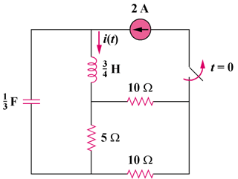
6(1–u(t)) A

Figure 16.59
For Prob. 16.36.

Solution

Step 1. First, we need to determine the initial conditions and then transform the circuit into the s-domain.

10 Ω

+

v

−

5 Ω

i₁

i

6A

10 Ω

Clearly i = 6 A. The current then travels through the parallel combination of the 10 ohm resistor and the combined 15 ohm resistance. i₁ = 6[(15)(10)/(15+10)]/(15) = 2.4 A. Therefore, v(0) = 5x2.4 = 12 V and i(0) = 6 A. We also note that the two 10 ohm resistors are in series and the combination is in parallel with the 5 ohm resistor resulting in a 100/25 = 4 ohm resistor.

The circuit in the s-domain is shown below.

–[12/s] + [3/s]I + [0.75s](I–6/s) + 4I = 0.

4 Ω

0.75s

I

6/s

7/s

+
−

3/s

I

Step 2. [(s²+5.333s+4)/(4s/3)]I = 4.5+12/s = 4.5(s+2.667)/s or

I = 6(s+2.667)/[(s+0.903)(s+4.43)] = [A/(s+0.903)]+[B/(s+4.43)] where

A = 6(–0.903+2.667)/(–0.903+4.43) = 6x1.764/3.527 = 3.001 and
B = 6(–4.43+2.667)/(–4.43+0.903) = 6x(–1.763)/(–3.527) = 2.999 or

i(t) = [3.001e^{–0.903t}+2.999e^{–4.43t}]u(t) amps.

